**Random Forest Algorithm Data Replication on Orange**

、

Reproducing Framework:

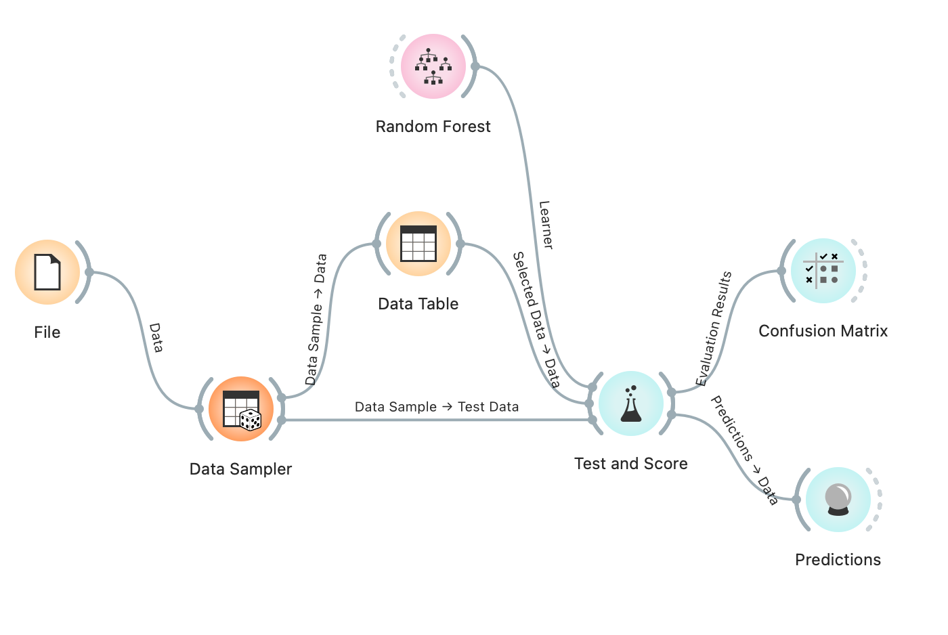

Dataset:

Data Science Salaries 2024

<https://www.kaggle.com/datasets/sazidthe1/data-science-salaries?resource=download>

Attributes:  
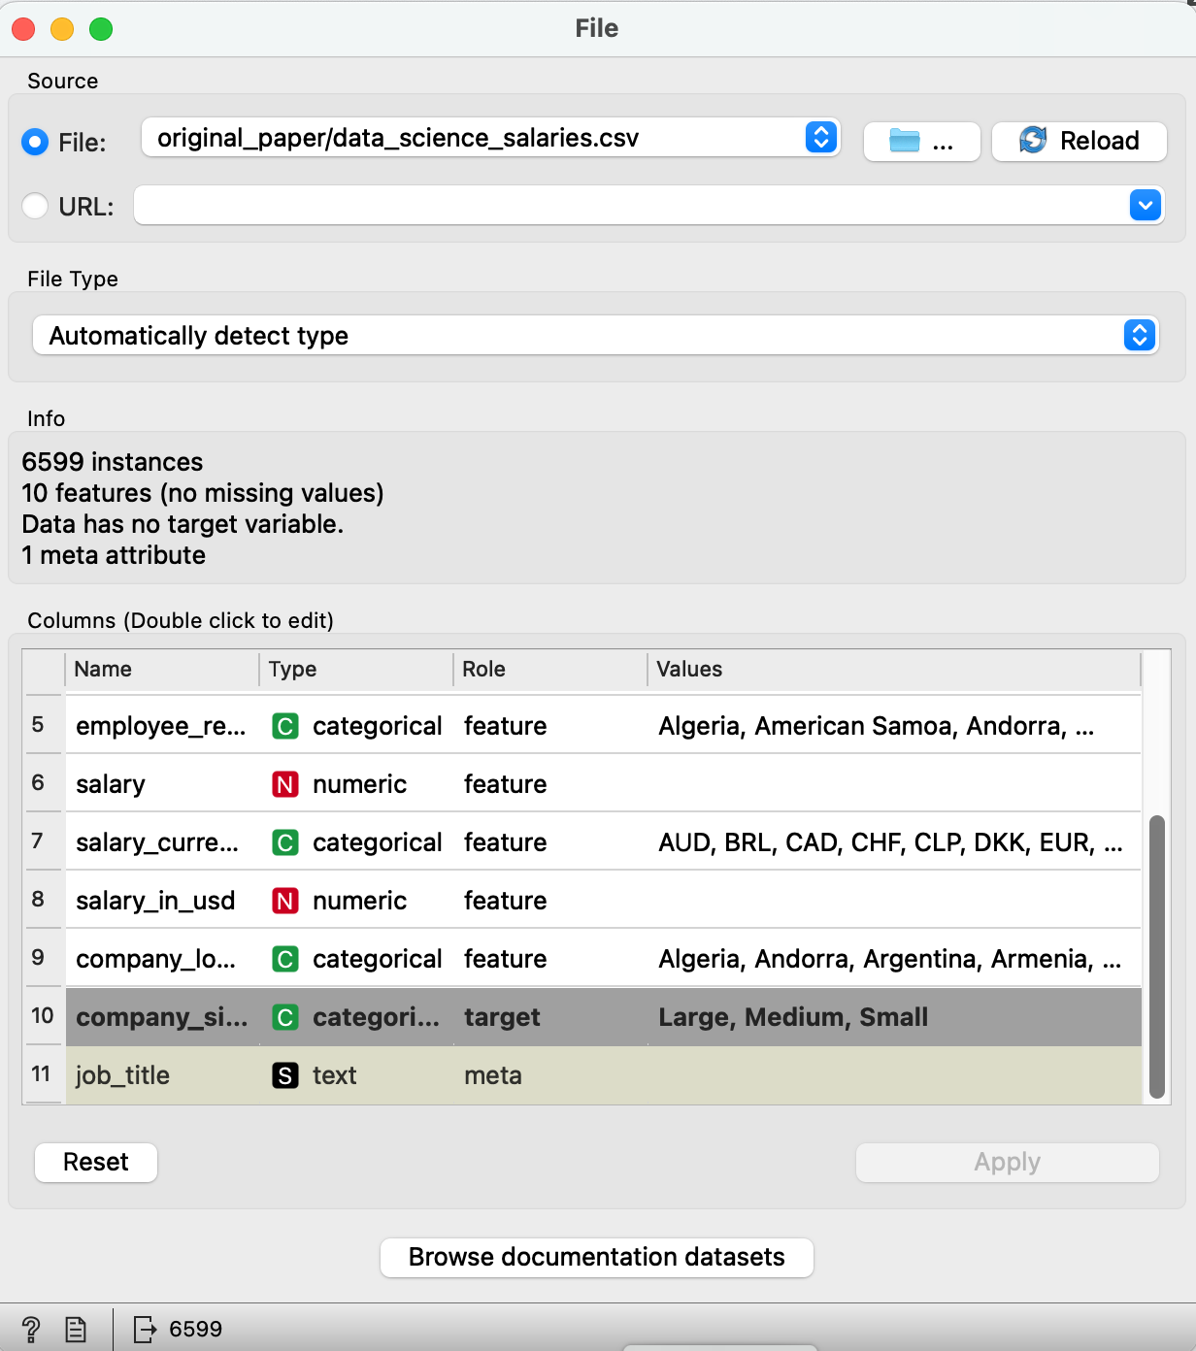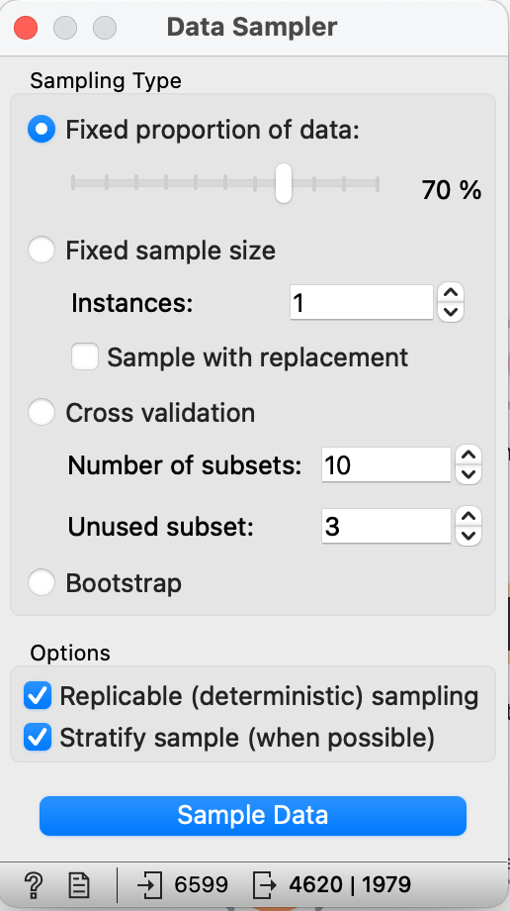

Test Result:  
